Misc.02: Domain model design
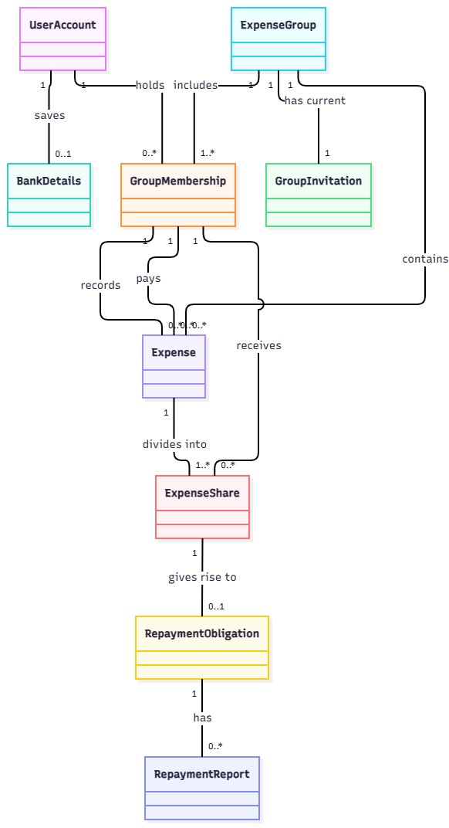
classDiagram
direction TB

UserAccount "1" -- "0..1" BankDetails : saves
UserAccount "1" -- "0..*" GroupMembership : holds
ExpenseGroup "1" -- "1..*" GroupMembership : includes
ExpenseGroup "1" -- "1" GroupInvitation : has current
ExpenseGroup "1" -- "0..*" Expense : contains
GroupMembership "1" -- "0..*" Expense : records
GroupMembership "1" -- "0..*" Expense : pays
Expense "1" -- "1..*" ExpenseShare : divides into
GroupMembership "1" -- "0..*" ExpenseShare : receives
ExpenseShare "1" -- "0..1" RepaymentObligation : gives rise to
RepaymentObligation "1" -- "0..*" RepaymentReport : has

This assumes that only one group invitation link is valid at a time. After a certain period of time (e.g 7 days), the link is invalidated.

Misc.03: Class diagram draft
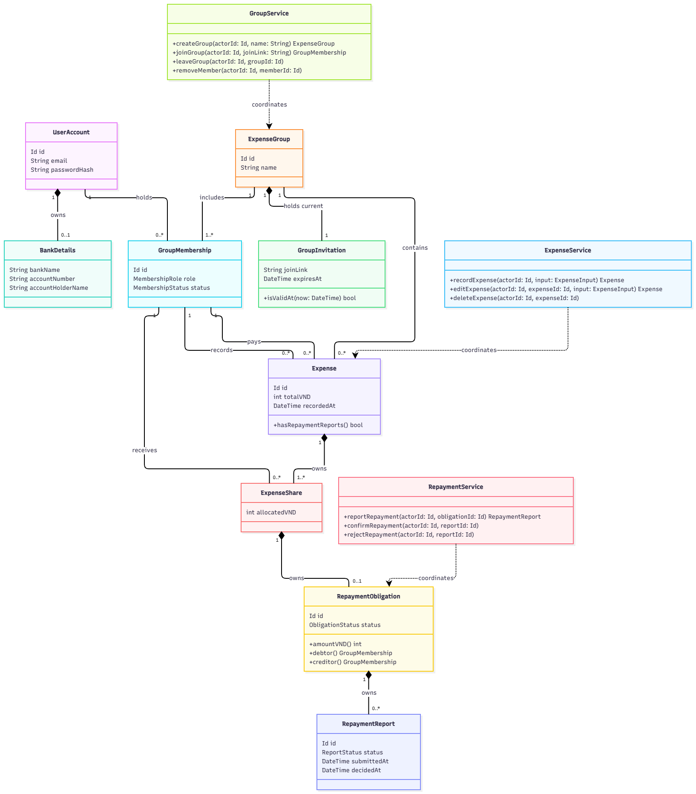
classDiagram
direction TB

class UserAccount {
Id id
String email
String passwordHash
}
class BankDetails {
String bankName
String accountNumber
String accountHolderName
}
class ExpenseGroup {
Id id
String name
}
class GroupMembership {
Id id
MembershipRole role
MembershipStatus status
}
class GroupInvitation {
String joinLink
DateTime expiresAt
+isValidAt(now: DateTime) bool
}
class Expense {
Id id
int totalVND
DateTime recordedAt
+hasRepaymentReports() bool
}
class ExpenseShare {
int allocatedVND
}
class RepaymentObligation {
Id id
ObligationStatus status
+amountVND() int
+debtor() GroupMembership
+creditor() GroupMembership
}
class RepaymentReport {
Id id
ReportStatus status
DateTime submittedAt
DateTime decidedAt
}

class GroupService {
+createGroup(actorId: Id, name: String) ExpenseGroup
+joinGroup(actorId: Id, joinLink: String) GroupMembership
+leaveGroup(actorId: Id, groupId: Id)
+removeMember(actorId: Id, memberId: Id)
}
class ExpenseService {
+recordExpense(actorId: Id, input: ExpenseInput) Expense
+editExpense(actorId: Id, expenseId: Id, input: ExpenseInput) Expense
+deleteExpense(actorId: Id, expenseId: Id)
}
class RepaymentService {
+reportRepayment(actorId: Id, obligationId: Id) RepaymentReport
+confirmRepayment(actorId: Id, reportId: Id)
+rejectRepayment(actorId: Id, reportId: Id)
}

UserAccount "1" *-- "0..1" BankDetails : owns
UserAccount "1" -- "0..*" GroupMembership : holds
ExpenseGroup "1" -- "1..*" GroupMembership : includes
ExpenseGroup "1" *-- "1" GroupInvitation : holds current
ExpenseGroup "1" -- "0..*" Expense : contains
GroupMembership "1" -- "0..*" Expense : records
GroupMembership "1" -- "0..*" Expense : pays
Expense "1" *-- "1..*" ExpenseShare : owns
GroupMembership "1" -- "0..*" ExpenseShare : receives
ExpenseShare "1" *-- "0..1" RepaymentObligation : owns
RepaymentObligation "1" *-- "0..*" RepaymentReport : owns

GroupService ..> ExpenseGroup : coordinates
ExpenseService ..> Expense : coordinates
RepaymentService ..> RepaymentObligation : coordinates

# | Member | Tool | Task / purpose | How the output was verified and changed
1 | Nguyễn Hoàng Tiến | ChatGPT | Draft separate conceptual domain and design-level class diagrams in Mermaid. | Compared the entities and relationships with the PA2 SRS.
2 | Nguyễn Hoàng Tiến | ChatGPT | Review the multiplicity between repayment obligations and reports. | Checked BR-13 against the SRS requirement to retain rejected reports.
3 | Nguyễn Hoàng Tiến | ChatGPT | Clarify how a repayment obligation represents its amount. | Traced the amount to ExpenseShare.allocatedVND. Reviewed the draft’s amountVND() accessor and identified /amountVND: int as a UML notation for the same derived value.
5 | Nguyễn Hoàng Tiến | ChatGPT | Decide whether to add foreign keys to class domain in object oriented design. | Checked that the class diagram already associates GroupMembership with ExpenseGroup and UserAccount. Identified groupId and userId as references to documents in the MongoDB data model, with a separate membership ID to preserve history when a user rejoins.

Note: This design assumes that each expense group can have at most one valid invitation link at a time (the actual design for this has not been documented in previous documents). Each link expires a fixed period after it is issued, for example, seven days.

